|  |  |
| --- | --- |
|  | **Year 11 ATAR Human Biology**  **Test – Reproduction and Development** |

|  |  |  |
| --- | --- | --- |
| **Name:** | **Date:** | **Score: /** |

**Assessment type:** Test

**Conditions**

Time for the task: 55 minutes

**Task weighting** - 8%

Total marks: 68

|  |  |  |
| --- | --- | --- |
|  | Available Marks | Your Marks |
| Multiple Choice | 10 |  |
| Short Answer | 38 |  |
| Extended Response | 20 |  |
| Total | 68 |  |

**Section 1: Multiple-choice (10 marks)**

This section has 10 questions. Answer all questions by circling the answer of your choice.

1. Human chorionic gonadotropin (HCG) hormone stimulates the:
2. maintenance of the corpus luteum during early stages of pregnancy.
3. production of progesterone.
4. production and development of a mature ovum, in the female, and the production of sperm in the seminiferous tubules, in the male.
5. vascularisation and glandurisation of the endometrium, resulting in it becoming thickened.
6. The optimum time to have sexual intercourse to increase the chances of fertilisation occurring would occur:
7. on day 1 of the menstrual cycle.
8. on day 28 of the menstrual cycle.
9. on day 14 of the menstrual cycle.
10. on day 7 of the menstrual cycle.
11. Gametogenesis produces:
    1. 4 viable sperm cells in males, each with N chromosomes.
    2. 4 viable egg cells in females, each with N chromosomes.
    3. 2 viable sperm cells in males, each with 2N chromosomes.
    4. 1 viable egg cell in females with 2N chromosomes.

1. Fertilisation is best described as:
   1. the fusion of the ovum and sperm to form a blastocyst.
   2. the breakdown of the corona radiata and zona pellucida.
   3. the fusion of the male and female pronuclei to form a zygote.
   4. the fusion of the two diploid gametes to form a haploid zygote.
2. Stage three of the labour process involves:
   1. contractions of the uterus and expulsion of the placenta.
   2. contractions of the uterus and production of colostrum in the breast.
   3. the expulsion of the baby from the birth canal.
   4. an increase in uterine contractions.
3. The cells contained in the zygote are classed as:
   1. totipotent stem cells.
   2. pluripotent stem cells.
   3. multipotent stem cells.
   4. proliferated stem cells.

Use the diagram of the male reproductive system below to answer questions 4 and 5.

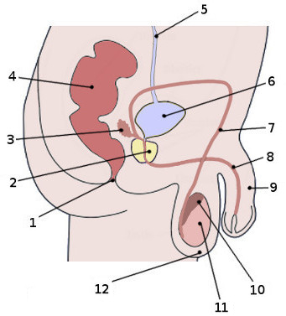

1. What is the name of the structure labelled 2 on the diagram above?
2. Urethra
3. Prostate gland
4. Bladder
5. Vas deferens
6. What is the function of the structure identified in question 7?
7. Produces a fluid that neutralises and lubricates the urethra.
8. Produces seminal fluid which nourishes and transports sperm.
9. Carries semen and urine out of the body
10. Stores mature sperm.
11. The ectoderm layer develops into several body systems and organs in an embryo. This includes the:
    1. reproductive system.
    2. nervous system.
    3. skeletal system.
    4. bones.
12. The function of the ductus arteriosus in the foetus is to allow blood to:
    1. bypass the right atrium and flow directly into the aorta.
    2. bypass the lungs and flow directly into the aorta.
    3. pass from the left atrium directly into the right atrium.
    4. bypass the liver and flow to the inferior vena cava before entering the heart.

**End of Section 1 – Turn over for Section 2**

**Section 2: Short answer (38 marks)**

This section has three questions. Answer all questions. Write your answers in the spaces provided.

______________________________________________________________________________

**Question 11 (15 marks)**

A

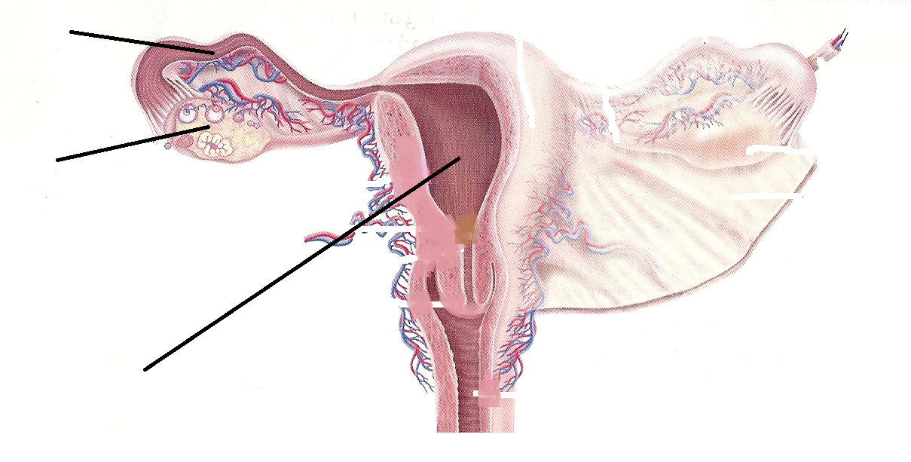

B

C

1. Examine the diagram above and complete the table below.

|  |  |  |
| --- | --- | --- |
| **Structure** | **Name of Structure** | **Role/Function** |
| A |  |  |
| B |  |  |
| C |  |  |

(3 marks)

1. 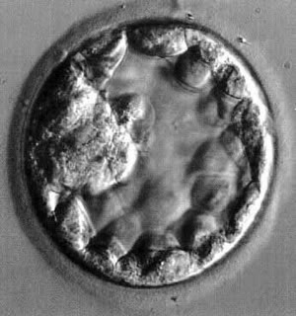Immediately following fertilisation, the zygote begins to divide to form a solid ball of cells. As cell division continues, the cells arrange themselves into a hollow ball of cells as seen in the micrograph image shown below.

1. What is the name given to this hollow ball of cells?_____________________________

(1 mark)

Small projections from this hollow ball of cells develop and penetrate into the endometrium forming the foetal component of the placenta, the site of exchange of substances between the mother and developing baby.

1. What name is given to these projections?

____________________________________________________________________________

(1 mark)

1. Using the figure below, label the following:



A:________________________________ C: ___________________________

(2 marks)

1. Describe one function of E.

________________________________________________________________________

* 1. mark)

1. Briefly describe three (3) functions of the placenta.

______________________________________________________________________________

______________________________________________________________________________

______________________________________________________________________________

(3 marks)

1. Name **two** substances that would be in higher concentration in the umbilical vein than in

the umbilical artery.

________________________________________________________________________________________________________________________________________________ (2 marks)

1. Describe how the foetal blood system is kept separate from that of the mother.

________________________________________________________________________________________________________________________________________________________________________________________________________________________________________________________________________________________________

(2 marks)

**Question 12 Relates to the diagram below (8 marks)**

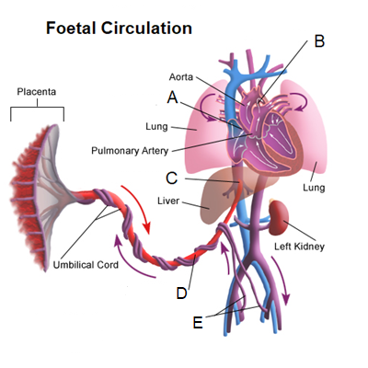

Using the diagram above, label the following:

a) A ____________________________ B __________________________

(2 marks)

b) Describe the function of C.

____________________________________________________________________________

____________________________________________________________________________

(2 marks)

1. Identify structures D and E, and describe their functions.

D: ____________________________________________________________

________________________________________________________________________

________________________________________________________________________

E: ____________________________________________________________

_______________________________________________________________________

_______________________________________________________________________ (4 marks)

**Question 13 (9 marks)**

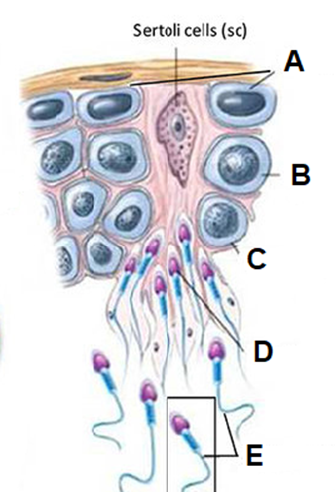

1. Identify the cell stages of spermatogenesis.

|  |  |
| --- | --- |
| **A** |  |
| **B** |  |
| **C** |  |
| **D** |  |
| **E** |  |

(5 marks)

1. Sperm production occurs within the testes. Name the structure in which this process takes place and give an advantage of this structure being tightly coiled.

___________________________________________________________________

___________________________________________________________________

___________________________________________________________________

(2 marks)

1. The first stage of the fertilisation of an oocyte by a single spermatozoan involves the acrosome. Describe the role of the acrosome during the first stage of fertilisation.

________________________________________________________________________________________________________________________________________________________________________________________________________________________________________________________________________________________________

(2 marks)

**Question 14 (6 marks)**

1. In women the menstrual cycle is controlled by hormones secreted from the pituitary gland and the ovary. The chart below lists **some** of the events that occur during the menstrual cycle. They are not in the correct order.

|  |  |
| --- | --- |
|  | **Event** |
| A | FSH secreted by the pituitary |
| B | Oestrogen stimulates growth of the endometrium |
| C | Follicles begin to mature in the ovary |
| D | Ovulation occurs |
| E | Oestrogen is secreted by follicles |
| F | LH is secreted by the pituitary gland |
| G | Corpus luteum develops |

* 1. List the stages in the correct sequence beginning at Day 1 of the menstrual cycle.

|  |  |  |  |  |  |  |
| --- | --- | --- | --- | --- | --- | --- |
|  |  |  |  |  |  |  |

(3 marks)

* 1. Describe the role of the corpus luteum in the ovarian and menstrual cycles.

____________________________________________________________________________________________________________________________________________________________________________________________________________________________________________________________________________________________ (3 marks)

**End of Section 2 – Turn over for Section 3**

**Section 3: Extended answer (20 marks)**

This section has one question. Write your answers in the spaces provided.

______________________________________________________________________________

**Question 41 (20 marks)**

1. The male reproductive system consists of a number of structures that all contribute to the production and transport of sperm. Name and explain the role of the three accessory glands found in the male reproductive system. (11 marks)

____________________________________________________________________________________________________________________________________________________________________________________________________________________________________________________________________________________________________________________________________________________________________________________________________________________________________________________________________________________________________________________________________________________________________________________________________________________________________________________________________________________________________________________________________________________________________________________________________________________________________________________________________________________________________________________________________________________________________________________________________________________________________________________________________________________________________________________________________________________________________________________________________________________________________________________________________________________________________________________________________________________________________________________________________________________________________________________________________________________________________________________________________________________________________________________________________________________________________________________________________________________________________________________________________________________________________________________________________________________________________________________________________________________________________________________________________________________________________________________________________________________________________________________________________________________________________________________________________________________________________________________________________________________________________________________________________________________________________________________________________________________________________________________________________________________________________

1. During embryonic development the inner cell mass of the blastocyst will differentiate. The name given to a cell that can differentiate into any type of tissue is a ‘stem’ cell.

Name the 3 types of stem cells, describe their potency and explain where they can be found. (9 marks)

______________________________________________________________________________________________________________________________________________________________________________________________________________________________________________________________________________________________________________________________________________________________________________________________________________________________________________________________________________________________________________________________________________________________________________________________________________________________________________________________________________________________________________________________________________________________________________________________________________________________________________________________________________________________________________________________________________________________________________________________________________________________________________________________________________________________________________________________________________________________________________________________________________________________________________________________________________________________________________________________________________________________________________________________________________________________________________________________________________________________________________________________________________________________________________________________________________________________________________________________________________________________________________________________________________________________________________________________________________________________________________________________________________________________________________________________________________________________________________________________________________________________________________________________________________________________________________________________________________________________________________________________________________________________________________________________________________________________________________________________________________________

**END OF TEST**